ADRIAN TURION |  | Avenue de Sainte-Clotilde 9  1205 Geneva, Switzerland | 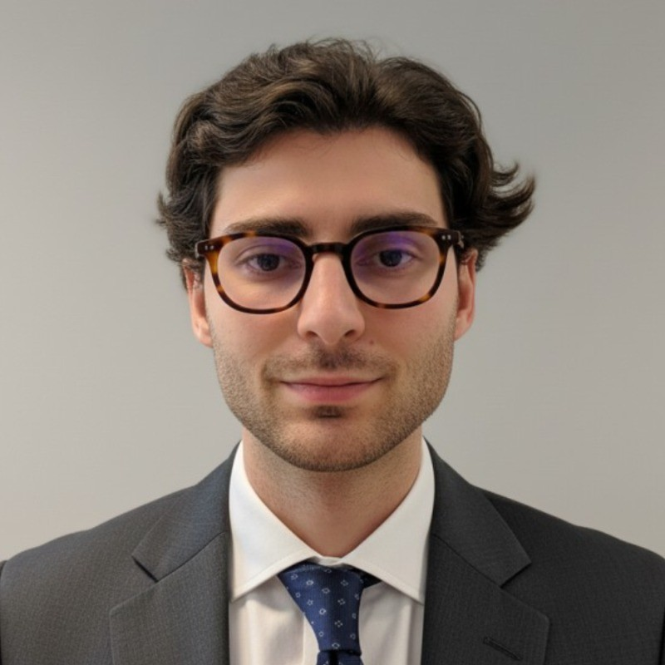
turionadrian@gmail.com | Swiss | 10.11.2000 |  | +41 77 262 37 96
INTRODUCTION
M&A analyst with hands-on experience in financial modeling, P&L analysis, and cross-border deal execution across 10+ mandates valued EUR 5M-50M. Built automated dashboards tracking KPIs and conducted variance analysis on monthly results for a CHF 50M subsidiary. Eager to apply analytical rigor and collaborative mindset to Trafigura's Deals Desk and Operations rotations.
WORK EXPERIENCE
Auraïa Capital Advisory – Small & Mid Cap Cross-border M&A Boutique  Mergers & Acquisitions Analyst (Converted internship into full-time position) |  | Geneva, Switzerland  Aug 2024 – Current
- Led end-to-end execution in a lean 3-person deal team across 10+ live mandates: sourcing targets, building valuation models (DCF, LBO, trading comps), coordinating due diligence, and managing negotiations through closing
- Built detailed financial models and prepared client presentations for Board meetings and investor pitches; maintained buyer universes of 30+ potential acquirers per mandate and coordinated data room management
- Managed relationships with clients, legal advisors, and counterparties throughout transaction lifecycle; reconciled positions daily with stakeholders across Europe, US, and Asia to ensure accurate deal tracking

RC Group – Currently under LBO with Crédit Mutuel Equity  Mergers & Acquisitions Intern |  | Paris, France  Feb 2024 – Aug 2024
- Worked directly with CEO of Healthcare and Retail divisions on evaluating acquisition targets in France and Belgium; prepared investment memos with market analysis and financial projections; conducted financial due diligence on targets with EUR 10M-30M revenues

Europ Assistance – Subsidiary of Generali Insurance  Financial Analyst Intern |  | Geneva, Switzerland  Apr 2023 – Aug 2023
- Built automated financial dashboards in Excel and PowerBI to track KPIs for 5 business units; performed variance analysis on monthly P&L results and investigated discrepancies for CFO reporting; developed new cost allocation model improving profitability analysis

LEADERSHIP
- McKinsey Case Finalist: Developed data-driven model to forecast black swan events using order book data and statistical arbitrage; presented to Keyrock management with CHF 200K revenue impact
- AIESEC Associate: Led post-COVID financial recovery by sourcing corporate leads and negotiating partnerships; closed 3 deals generating CHF 60K annual revenue and +40% volunteer placements
- Founded Screeny.ai: Built AI software for M&A buyer identification adopted by 3 advisory firms; reduced search time from 10h+ to 20min through automated screening algorithms
EDUCATION
HEC Lausanne  Master of Science in Finance |  | Lausanne, Switzerland  2021 – 2024
- Cumulative GPA: 5.2/6.0 (Top 15% of the class cohort)
- Exchange programs at Waseda University (Tokyo, Japan) and Maastricht University (Maastricht, Netherlands)
- Relevant Coursework: Derivatives, Quantitative Risk Management, Corporate Governance & M&A, Fixed Income
- Thesis Topic: Synergies Analysis of the Merger between American Airlines & US Airways

Bachelor of Science in Management |  | 2018 – 2021
- Cumulative GPA: 4.7/6.0

Scientific Baccalaureate with Highest Honors (16.6/20) |  | Aix-en-Provence, France
ADDITIONAL INFORMATION
Languages:  Computer:  Interests:  References: | French (Native, C2), Spanish (Native, C2), English (Fluent, C1), German (Business proficient, B2-C1)  Financial Modeling | Valuation | P&L Analysis | Excel, PowerBI | EN, FR, ES  Geopolitics, Badminton (Provence regional finalist), Gym, Real use cases of Artificial Intelligence  Guillaume Arnaldez – Ex-Director at Auraïa Capital Advisory, guillaume.arnaldez@auraia.ch  Sacha Caravatti – CFO at Europ Assistance Switzerland, scaravatti@europ-assistance.ch

